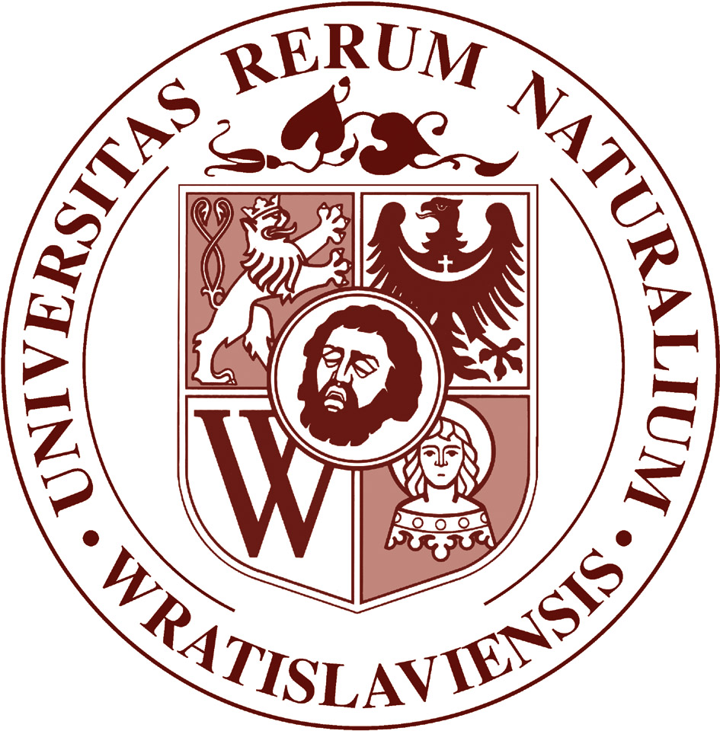
29. Congress of Polish Society of Soil Science
Soil resources and sustainable development
31 August – 3 September 2015, Wroclaw
http://www.org.up.wroc.pl/igosr/PTG29/

Registration Form

Name and surname:
Country: e-mail:
Affiliation (with address):

Presentation title (concerns only the first author):

Preferred form of presentation: poster oral

Provisional date of: arrival departure
I wish to arrange for me accommodation in student dormitory: yes no
Accompanying person: yes no
Preferred mid-week (2.09.2015) field session (choose one):
A. Phaeozems and chernozems of Wrocław Plaine
B. Fluvisols and marsh meadow habitats of Odra Valley
C. Soils of Legnica - Głogów Copper Mining Area

I will participate in post-conference (4-5.09.2015) field trip: yes no

Further details on arrival and accommodation will be sent after May 31, 2015.

