Conference Venue
Didactic and Scientific Center
Wroclaw University of Environmental
and Life Sciences,
pl. Grunwaldzki 24a
The precise location is given on website.

Applications and registration
Registration form is available on the conference websiite.
All participants are asked to send registration form to the email ptg2015@up.wroc.pl to 31st of may 2015 .
Registration form should include:
- name and surname,
- scientifiic title/degree,
- workplace adress,
- e-mail, phone,
- title and form of presentation (oral or poster presentation) (send only first author),
- prefferred one day trip (during the Conference),
- notification of participation in post conference trip.
The confirmation of registration will be send by email before 30.06.2015, after registration fee payment.

Important dates
registration deadline 31.05.2015
2nd announcement 31.12.2014
reduced conference payment 31.12.2014
abstract submission deadline 1.03.2015
acceptance of abstract submission 15.03.2015
payment deadline 31.05.2015
3rd announcement ` 15.07.2015
full paper submission deadline 31.08.2015

Organizing Committee
Jerzy Weber (chairman)
Cezary Kabała (v-ce chairman)
Beata Chodor (secretary)
Katarzyna Szopka (secretary)
Jakub Bekier
Adam Bogacz
Irmina Ćwieląg-Piasecka
Magdalena Dębicka
Bernard Gałka
Elżbieta Jamroz
Paweł Jezierski
Anna Karczewska
Jarosław Kaszubkiewicz
Dorota Kawałko
Andrzej Kocowicz
Jolanta Korzeniowska
Beata Łabaz
Marian Marzec
Agnieszka Medyńska-Juraszek
Zbigniew Perlak
Izabella Pisarek
Stanisława Strączyńska
Rafał Tyszka
Jarosław Waroszewski
Przemysław Woźniczka

Contact
Institut of Soil Science and Environmental Protection , Wroclaw University of Environmental and Life Sciences
ul. Grunwaldzka 53, 50-357 Wrocław
http://www.org.up.wroc.pl/igosr
tel./fax: 071 3205604
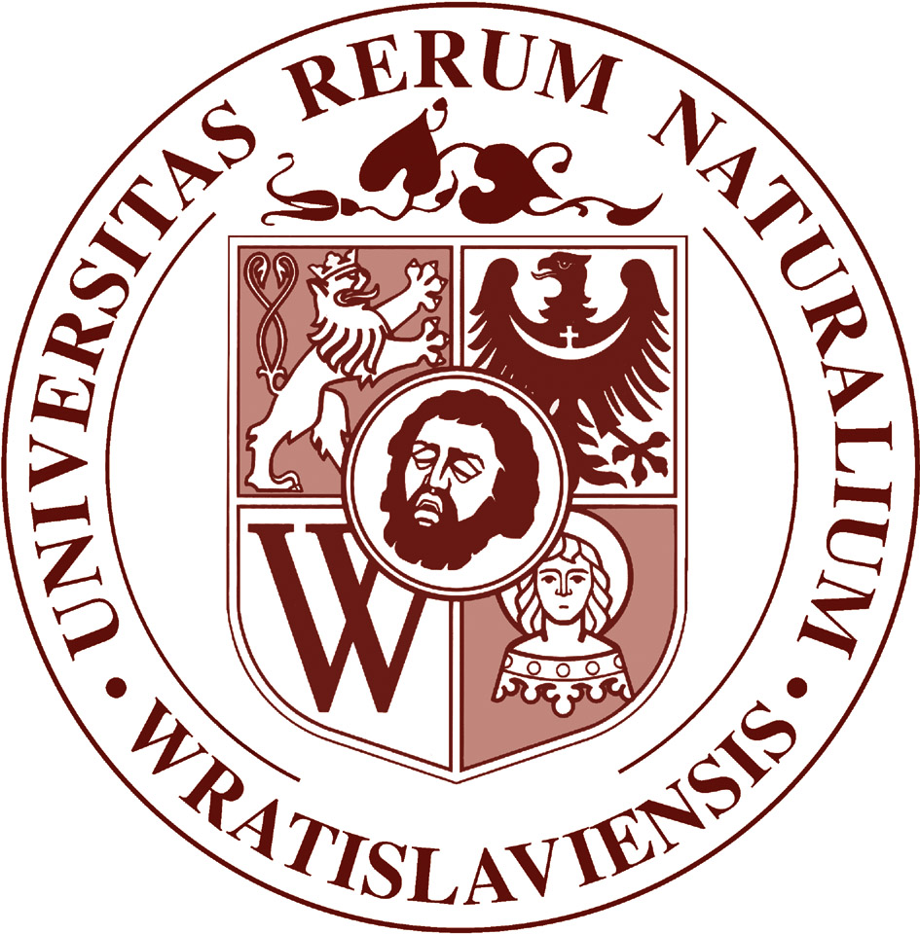
e-mail: ptg2015@up.wroc.pl

2nd Announcement

29. Congress of
Polish Society of Soil Science

Soil Resources and Sustainable Development
http://www.org.up.wroc.pl/igosr/PTG29/


the organizer:
Institut of Soil Science and Environmental Protection , Wroclaw University of Environmental and Life Sciences
and
Polish Society of Soil Science,
Polish Humic Substances Society,
Committee of Soil Science and Agricultural Chemistry Polish Academy of Sciences
honorary patronage
Rector of
Wroclaw University of Environmental and Life Sciences
Prof. dr. hab. Romana Kołacz

Wrocław

31.08 – 3.09.2015
Scientific Committee
Jerzy Weber – the Chairman
Zbigniew Zagórski (President of the PSSS)
Piotr Banaszuk (Białystok)
Stanisław Baran (Lublin)
Elżbieta Bielińska (Lublin)
Renata Bednarek (Toruń)
Bolesław Bieniek (Olsztyn)
Stanisław Brożek (Kraków)
Józef Chojnicki (Warszawa)
Halina Dąbkowska-Naskręt (Bydgoszcz)
Bożena Dębska (Bydgoszcz)
Ryszard Dębicki (Lublin)
Jacek Długosz (Bydgoszcz)
Marek Drewnik (Kraków)
Jerzy Drozd (Wrocław)
Tadeusz Filipek (Lublin)
Magdalena Frąc (Lublin)
Sławomir Gonet (Bydgoszcz)
Józef Horabik (Lublin)
Cezary Kabała (Wrocław)
Stanisław Kalembasa (Siedlce)
Janina Kaniuczak (Rzeszów)
Anna Karczewska (Wrocław)
Jarosław Kaszubkiewicz (Wrocław)
Jan Kucharski (Olsztyn)
Jerzy Lipiec (Lublin)
Jan Łabętowicz (Łabętowicz)
Barbara Maliszewska-Kordybach (Puławy)
Anna Miechówka (Kraków)
Edward Meller (Szczecin)
Andrzej Mocek (Poznań)
Wojciech Owczarzak (Poznań)
Wiera Sądej (Olsztyn)
Stefan Skiba (Kraków)
Piotr Skłodowski (Warszawa)
Anna SŁowińska-Jurkiewicz (Lublin)
Halina Smal (Lublin)
Zofia Spiak (Wrocław)
Stanisława Strączyńska (Wrocław)
Anna Wójcikowska-Kapusta (Lublin)
Programme
Both oral and poster presentations will be presented in Polish or English.
PAPER SESION
One Plenary and 6 topic sessions are planed:
1. Soil genesis and classification
2. Soil chemistry and biological processes
3. Soil organic matter transformation
4. Physical and physicochemical processes
5. Soil degradation and reclamation
- Suitable use of soil resources

During the sessions, oral presentations in English will be preferred. In all sessions keynote lectures will be presented. The list of keynote lectures is shown on the conference website. The final programme will be printed in the 3rd announcement.
FIELD SESSIONS:
- one day trip (by choice), 2.09.2015
- Post – Congress two days tour, 4-5.09.2015 (additional cost 400 zł).
Detailed information about field sessions are given on Conference website.

Conference fee
 | Payment deadline
 | 31.12.2014 | 31.05.2015 | 20.08.2015
PhD Students | 175 Euro | 225 Euro | 275 Euro
Members of Polish Society of Soil Science | 200 Euro | 250 Euro | 300 Euro
Other participants | 225 Euro | 275 Euro | 325 Euro
Registration fee includes a conference package, access to plenary and poster sessions, coffee breaks, one day field session (2.09.2015) banquet and meals (from dinner 31.08 to lunch 3.09.2015).
The fee does not include accommodation, publication of full text and post-Congress tour (additional cost 400 zł). Only payment via bank transfer will be accepted.
Transfers should be made to:

Raiffeisen Bank Polska S.A.
39 1750 0012 0000 0000 2506 9536
Polish Humic Substances Society
ul. Grunwaldzka 53, 50-357 Wroclaw
The bank transfer must indicate the following title of payment „PTG 2015 name and surname”.

Accomodation
Rooms have been pre-booked for participants in the student dormitory from 31.08 to 4.09.2015 r.
The localization and prices will be given on website in January 2015.

Abstracts
Participants are kindly encouraged to submit abstracts written in English before 1.03.2015. Abstract template available on conference website.

Full paper
We intend to publish oral and poster contributions in Soil Science Annual and Polish Journal of Soil Science. Participants interested in publication of full paper should submit manuscript to the registration desk on the first day of conference.

